Orders entered by hand
An order you type in is a quotation until you confirm it. You confirm the order, then you create the invoice. Confirm does not create the invoice, and it does not email one.

1. Start the quotation
Sales → Orders → New.
Set the customer. Add the products. Add the shipping charge with Add shipping before you confirm. Check the total.

2. When it should ship
If some units are not in the warehouse, set this before you confirm. Open Other Info and set Shipping Policy.
- As soon as possible ships the warehouse units now. The rest ships when it arrives.
- When all products are ready holds the order and ships everything together.

A website customer makes this choice at checkout. On an order you enter yourself, you set it.

3. Confirm the quotation
Click Confirm when the customer and the lines are right. The status becomes Sales Order.
Send on a quotation emails the quote. Confirm is the button that places the order.
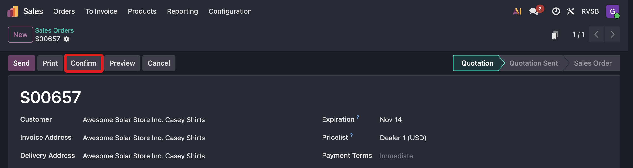
A quotation. Confirm is in the header. The status is Quotation.

4. Create the invoice
Create Invoice is now on the order. Click it and create the draft invoice.
On the invoice, click Confirm. That posts it. If the customer has paid, click Pay.
Leave Send alone. A retail customer is not emailed the invoice.
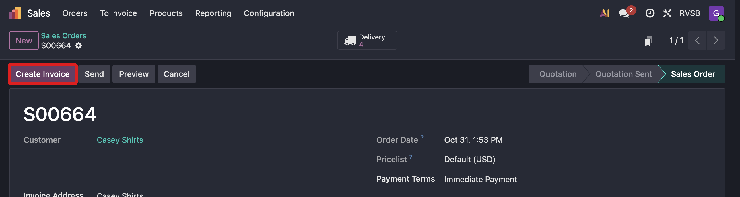
After the order is a Sales Order, Create Invoice is in the header.

5. The warehouse, and Victron
Confirm creates the pick. Follow the pick and ship SOP from there.
Units the warehouse cannot fill are added to the draft Victron purchase order. Casey gets the to-do Finish PO and send to Victron. Check the quantity and the price, confirm Victron can still fill it, then confirm the purchase order. Nothing is sent to Victron until then.
If the chatter says the purchase order was not created, set the Victron vendor under Inventory → Settings → Victron E-Order and create the RFQ by hand.

